國立陽明交通大學醫療人文跨領域研究中心
2022年國際學術研討會
National Yang Ming Chiao Tung University Interdisciplinary Medical Humanities Research Center International Conference
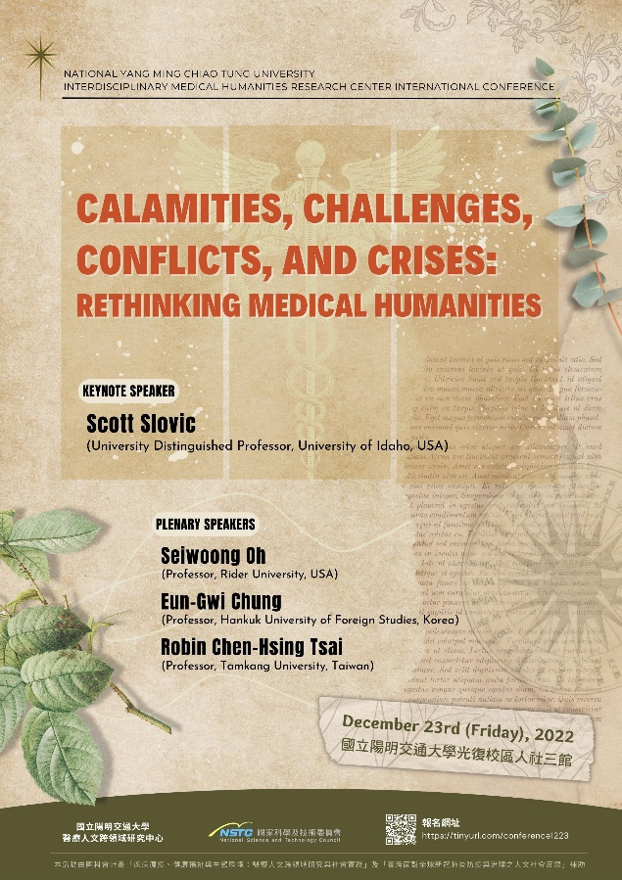
Calamities, Challenges, Conflicts, and Crises: Rethinking Medical Humanities
時間：2022年12月23日（五）
Date: December 23rd (Friday), 2022
地點：國立陽明交通大學光復校區人社三館
Venue: HSS Building 3, NYCU (Guang-fu Campus), Hsinchu City, Taiwan
報名https://tinyurl.com/conference1223


專題演講 Keynote Speaker
Anatomizing the Medical-Environmental Humanities: The Inextricability of Human Health and Environmental Health
Scott Slovic (University Distinguished Professor, University of Idaho, USA)

主題發表 Plenary Speakers
Aesthetics of Illness Narratives: “Interesting Facts” & “Yellow Wallpaper”
Seiwoong Oh (Professor, Rider University)
Writing as Dying: Autobiographical Medical Poems of Kim Hyesoon and Brenda Hillman
Eun-Gwi Chung (Professor, Hankuk University of Foreign Studies, Korea)
The Logic of Life: Ecoplasticity in Geraldine Brooks’ Year of Wonders
Robin Chen-Hsing Tsai (Professor, Tamkang University, Taiwan)
-

發表題目 Topics and Presenters (in alphabetical order)
“Aging and Self-knowledge in King Lear”
Chuan-haur Liu 劉川豪 (陽明交通大學醫療人文跨領域研究中心博士後研究員)
“The Apocalyptic Creation in Jeff VanderMeer’s Annihilation”
Catherine Ju-yu Cheng 鄭如玉 (逢甲大學外文系副教授)
“Crip Autoimmunity: Rethinking Care of the Selves”
Yu-Ching Wang 王榆晴 (臺灣大學外文系博士後研究員)
“Forces Shaping the Conditions of Our Life: An Interpretation of “Impermanence” through Philip Roth’s Polio Narrative Nemesis”
Kang-yen Chiu 邱剛彥 (陽明交通大學視覺文化研究所副教授)
“Healing and Body and Soul in Times of Crisis: Physicians and Plague Saints as Collaborators and Competitors in Venetian Renaissance Art”
Candida Syndikus 辛蒂庫絲 (臺灣師範大學藝術史研究所教授兼所長)
“A Heaven of Hell, a Hell of Heaven”: Epidemics, Leprosy, and Hope in Graham Greene’s A Burnt-Out Case
Hawk Chang 張崇旂 (香港教育大學文學與文化學系助理教授)
“A History of the Plague According to the Flea: Maggie O’Farrell’s Hamnet”
Yi-Peng Lai 賴怡芃 (中山大學外文系助理教授)
“A Piece of the Urban Sin’s History: On Syphilis Reportage in 1930s Shun Pao and the Transformation of Stylistics and Society”
Meng Jiajie 孟嘉杰 (新加坡南洋理工大學中文系碩士生)
“Restlessness Transformed: Revisiting the Metaphor of Tuberculosis
in Katherine Mansfield’s Journals and Letters”
Hannah Wen-Shan Shieh 謝文珊 (銘傳大學應用外語系助理教授)
“A Sight/Site to See: Gaze and Liminal Space in Eudora Welty’s 'A Visit of Charity’ (1941)”
Bo-Yuan Huang 黃柏源 (嘉義大學外文系助理教授)
“Towards a Panda Institute of Graphic Treatment: Retrieving Obsolete Past in Daniel Clowes’ Patience”
Pei-Ju Wu 吳佩如 (亞洲大學休閒與遊憩管理學系專案助理教授)

主辦單位：國立陽明交通大學醫療人文跨領域研究中心
聯絡資訊：國立陽明交通大學醫療人文跨領域研究中心 imhrc@nycu.edu.tw
經費來源：國科會計畫「疾病瘟疫、健康福祉與生態環境：醫療人文跨領域研究與社會實踐」及「臺灣面對全球新冠肺炎防疫與治理之人文社會反思」
海報設計／黃浥昀 flydodos@gmail.com

